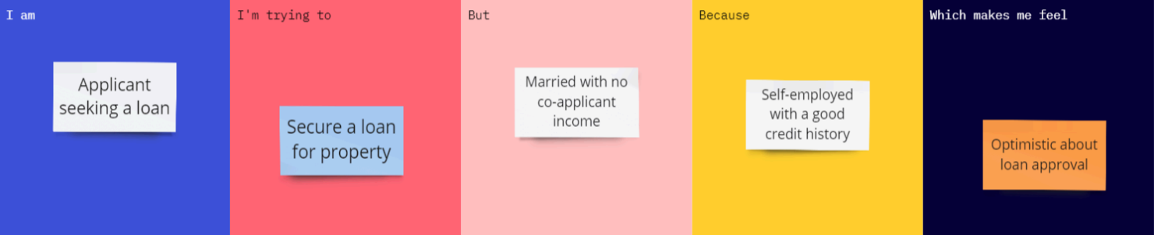
Project Initialization and Planning Phase
Date | 02 July 2026
Team ID
Project Name | Darshan Ease – Temple Darshan Ticket Booking System
Maximum Marks | 3 Marks

Define Problem Statements (Customer Problem Statement Template):
Create a problem statement to understand your customer's point of view. The Customer Problem Statement template helps you focus on what matters to create experiences people will love. A well-articulated customer problem statement allows you and your team to find the ideal solution for your customers' challenges. Throughout the process, you'll also be able to empathize with your customers, which helps you better understand how they perceive your product or service.
Example:


Problem Statement (PS) | I am (Customer) | I'm trying to | But | Because | Which makes me feel
PS-1 | A devotee planning to visit a temple for darshan. | Book a darshan slot in advance for a convenient date and time. | There is no simple online platform to check timings and reserve a slot. | I want to avoid long queues and uncertainty on the day of the visit. | Anxious about travelling without a confirmed slot.
PS-2 | A returning devotee who has booked darshan tickets before. | Quickly view my past and upcoming bookings. | I have to search through messages or paper receipts to find booking details. | I want easy access to my ticket and booking history in one place. | Reassured when everything is available in a single profile.
PS-3 | A temple administrator managing darshan bookings. | Track seat availability and issue tickets efficiently. | Bookings are currently managed through manual registers. | There is no centralized digital system for booking management. | Overwhelmed during peak festival seasons.

